INTEL PRODUCTS VIETNAM GREEN INITIATIVES

2011
FSC PAPER FOR BUSINESS CARDS
In order to support responsible use of forest resource, Intel started to use the Forest Stewardship Council Certified (FSC) Paper for business cards and envelopes printing. The FSC paper showed the products are made with consideration for people, wildlife and the environment. It guarantees that the trees harvested are replaced or allowed to regenerate naturally.
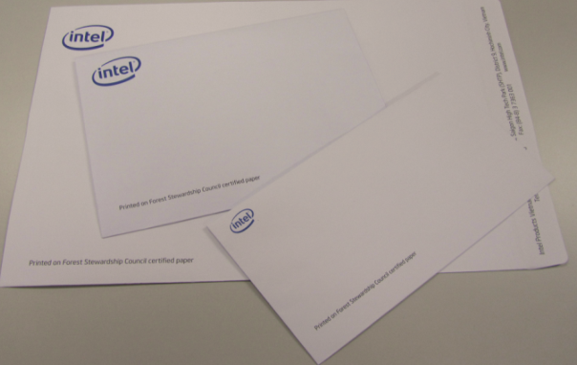
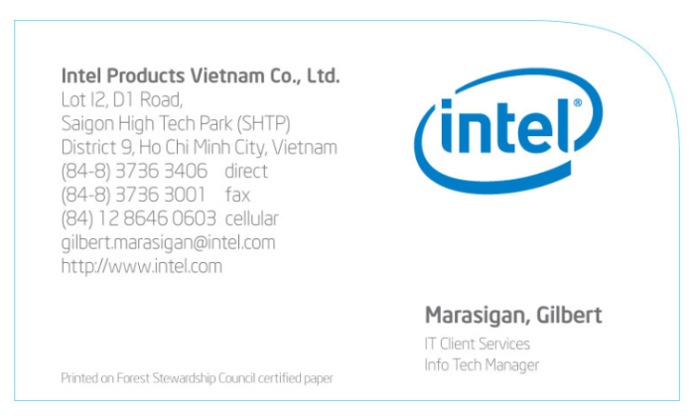

Office Cubicle Personal Trash Bin Removal
Office trash bins were replaced with designated satellite waste collection areas. This project not only improved employee participation on waste segregation, increased the recycle rate to 89% (above target), reduced office waste collection costs and more importantly promote health & wellness by encouraging people to stand up and take breaks – simplest and practical solution yet it has the highest impact to the environmental awareness of our very young employees. As the old saying goes, “we must teach our employees to do it right the first time.” This Best-Known-Method (BKM) is now being proliferated in other sites such as Chengdu (CD) and Arizona (AZ)

2012
VNAT SOLAR PHOTOVOLTAIC SYSTEM - THE LARGEST IN INTEL’S ASSEMBLY & TEST MANUFACTURING and FIRST SOLAR SYSTEM IN VIETNAM
Green energy investments are a key part of Intel’s global strategy to address the issue of climate change and Intel Vietnam factory plays a significant role towards this strategy. Intel is proud to showcase its investments in renewable energy and hope that it will be a catalyst for the country to create incentives to drive further investments in renewable energy. This solar system is the largest operating solar power system in HCMC and in Vietnam, and also the first and the largest Solar system across Intel’s Assembly-Test Manufacturing. It highlights our commitment to operating our manufacturing facilities with the lowest impact to the environment. The system operates in 3920 m2, consists of 1092 high efficiency photovoltaic panels, 21 inverters, 4000 meters of tension support cable and 10,000 meters of DC cables. In total 30 solar power engineers dedicated nearly 5000 man hours to complete the project. The project is now generating 321,000KWh of power offsets 221,300 Kg of CO2 emission yearly, equivalents the CO2 emission from 610 vehicles in HCMC a year.
Intel is a responsible member of the communities in which we live and work, and then the green energy project completely focuses on environmental protection, not for economic purpose. This project is also a model investment for those projects which government and other companies will start in near future.
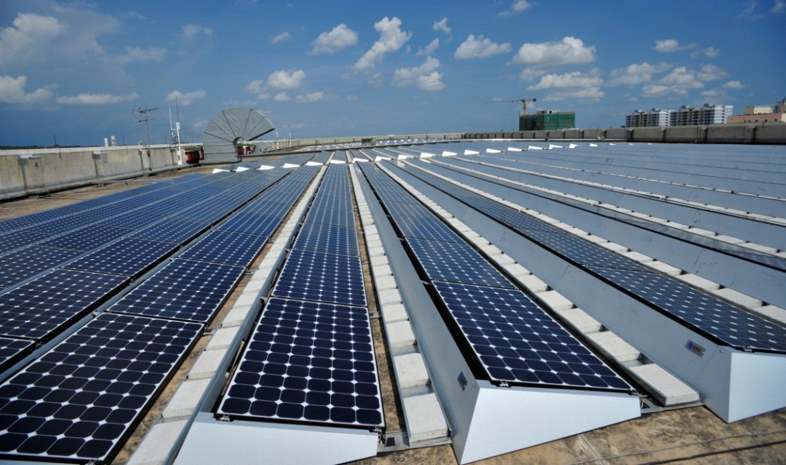

NEW AUTOMATED WATER FAUCET
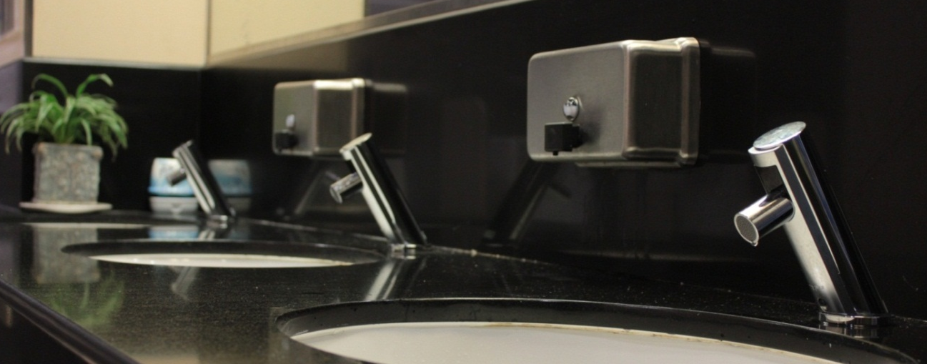
Water conservation project: Replaced the current faucets into sensor faucets in restrooms from all the buildings such as office, factory and warehouse, saving 40,000 m³/year of water using, and reducing the utility spends for city and waste water treatment by $ 25K.

2012 LEED CERTIFICATE FOR INTEL PRODUCTS VIETNAM OFFICE BUILDING


LEED (Leadership in Energy and Environmental Design Standard) This is an internationally recognized green building program that rank a building on a point based scale across five areas: Sustainable Sites, Water Efficiency, Energy and Atmosphere, Materials and Resources, Indoor Environmental Quality. On May 2012, Intel VN has registered the LEED Certificate for office building SS3 GPB and has been ranked Gold status on 12/12/2012 (which is between 60–79 points). SS3 the first LEED GOLD certified building in Ho Chi Minh City recognized by US Green Building Council. Being a LEED-certified building is important to us as it helps to lower our operating costs and increases our asset values; reduces the waste we send to landfills; makes our building energy and water efficient; provides a healthier and safer building for our employees and reduces harmful greenhouse gas emissions. In the next coming years, the same effort will be carried out to get our ATM and integrated warehouse building certified to LEED for Existing Buildings.

MINIMIZE PLASTIC BAG USAGE
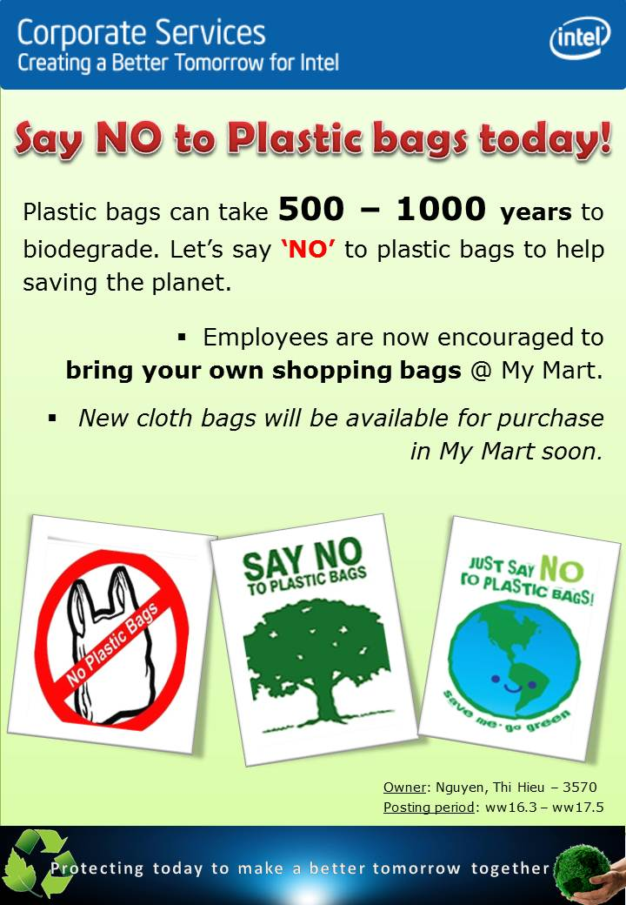
Say No to Plastic Bags at My-Mart. Starting Mar’12, My-Mart convenience store in partnership with Intel no longer provide free plastic bags for our employees instead encourage them bring their own re-usable bags or to buy a re-usable bag from My-mart when shopping. This helped increase awareness on the impact of plastic bags to the environment.

From Plastic to Eco-Bags: Starting Jul 2012, Intel initiated the replacement of the current plastic bags to a more environmentally friendly called “eco-bags”. Starting Q1’13, the new environmental tax will be applied to use of plastic bags.

Toner and Cartridge Recycling
Made possible the re-use of empty & broken printer toner/inkjet cartridges reducing hazardous waste generation from the site, saving about 10% of our storage space and a cost saving of $15,000 per year from purchase of new ink cartridges for IPV printers.
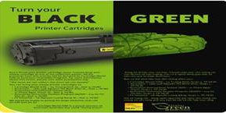

ENERGY SAVING PROJECTS in 2012 Intel Products Vietnam continue to incorporate energy efficient design in our equipment facilities
- 18 projects were implemented in 2012 with $90K capital investment
- Total annual savings : 2,158,535 kWh electricity & 63,399 m3 water
- Achieved the site target & exceed ~$61K compared with the global goal

Item | Project title | Project description | Actual saving
Item | Project title | Project description | Electricity (kWh) | Water (m3)
1 | Water Efficient Fixture | Replace existing faucets, urinals, flush valves with low flush types and sensor type & adjust old fixtures flow rate |  | 10,769
2 | GPB Timer Control | Install timer control for lighting near the window | 19,586
3 | ATEM | Install Efficiency Monitor Board for Chillers
4 | ATM Mezzanine Lighting Reduction | Turn off Mezzanine & Walkable Ceiling lighting in off-hour | 334,426
5 | Chiller Set point Optimize | Increase Chiller Set point from 5.6deg C to 6.1 deg C | 113,980
6 | Solar Panel | Install Solar Panel for GPB | 240,750
7 | Shutdown/Warmdown Saving | Turn off some facility equipments & manufacturing tools in shutdown days | 626,267 | 922
8 | ATM FFU Speed Reduction | Reduce phase 2 FFU speed | 58,491
9 | Water Usage Optimize | Optimize irrigation & leak finding |  | 51,708
10 | Conference Room AHU Set point Optimize | Recalculate load, adjust Set point for AHU3 for Conference room | 15,000
11 | Earth Day & Earth Hour | Turn off office lighting & some facility equipments and manufacturing tools in Earth Hour & Earth Day | 31,872
12 | Phase 2 Lighting Optimize | Turn off some emergency lighting in Phase 2 | 160,303
13 | GBP Off-hour Lighting Optimize | Turn off office lighting in off-hour | 46,077
14 | Tool bagging | Bag some tools when not in use | 445,130
15 | Implement High Bay Lighting Efficiency Measures at IW | Switch-Off High Bay Lighting at IW in areas where there's no rack | 66,874
 | Total |  | 2,158,535 | 63,399

2013
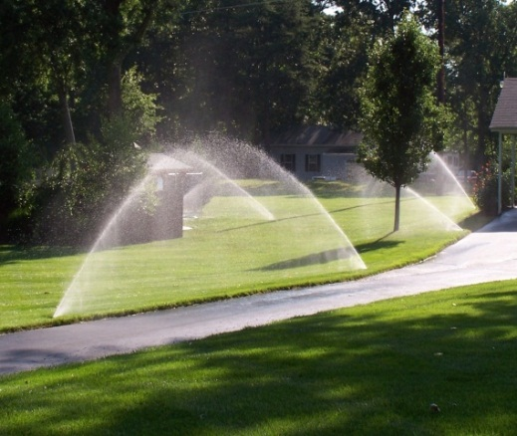
RO REJECT WATER RECLAIM AND USE FOR IRRIGATION. This project is currently in progress and is targeted to be completed by end of year. It will help save 58,000m3/year and $USD20K/year during the operational phase.

WE RECYCLE PROGRAM
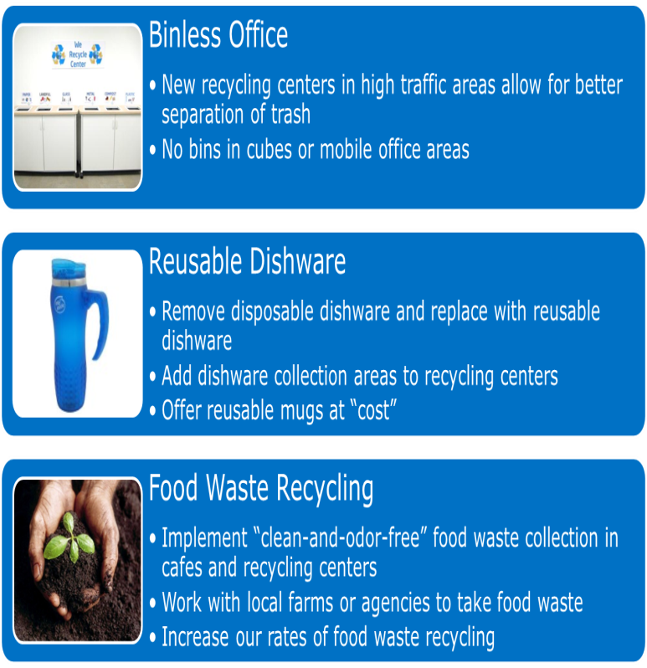
Every year, nearly one-third of food, or 1.3 billion tons, produced for human consumption around the world is wasted. That’s more than the weight of 3,500 empire state buildings! Last year alone, Americans used more than 140 tons of disposable dishware, including roughly 99 tons of Styrofoam containers and 44 tons of paper cups and plates. That’s a lot of waste. In today’s green-minded society, companies are looking at new ways to reduce, reuse and recycle.
Earlier 2013, Intel launched We Recycle, an employee initiative that aims to recycle 90 percent of the company’s solid waste – about 8,200 tons of it. To engage our employees and increase our company’s recycling rate, We Recycle introduced centralized areas for recycling at participating Intel sites to better manage food waste. Additionally, Intel cafeterias now have reusable dishware to reduce waste from disposable utensils. Over the past five years, we’ve recycled about 75 percent of our waste, so this new goal of recycling 90 percent in one year is an ambitious leap in the right direction. This environmental goal is also one of several employee-driven metrics that determine our annual employee bonus compensation.

ENERGY SAVING PROJECTS IN 2013
Item | Project list | Annual savings | Actual savings | ECD | Forcast Savings($) | Actual Savings($)
1 | T5 for Office 1+3 | 52,755 | 39,566 | 8-Apr-13 | 1,306 | 1,306
2 | T5 for Office 2 | 91,438 | 68,579 | 8-Apr-13 | 2,263 | 2,263
3 | VFD for MAH | 200,000 | 100,000 | 1-Jul-13 | 3,300 | 3,300
4 | VFD for Condenser water pump | 500,000 | 333,333 | 6-May-13 | 11,000 | 11,000
5 | Office HVAC optimize | 215,673 | 197,700 | 1-Feb-13 | 6,524 | 6,524
6 | Pilot Enthalpy control for 1 CT | 300,000 | 150,000 | 1-Jul-13 | 4,950 | 4,950
7 | DCC chilled water efficiency | 300,000 | 200,000 | 1-May-13 | 6,600 | 6,600
8 | Turn off WC normal lighting | 124,100 | 103,417 | 4-Mar-13 | 3,413 | 3,413
9 | Tool bagging | 613,200 | 459900 | 10-Mar-13 | 30,000 | 15,000
9 | Tool bagging | 10,000 | 7500
10 | Landscaping optimize | 47,815 | 41,344 | Feb-13 | 17,778 | 17,778
11 | Turn of exhaust in CUB | 170,000 | 99,167 | Jun-13 | 3,273 | 3,273
12 | Compressor running optimize | 650,000 | 487,500 | Apr-13 | 16,088 | 16,088
13 | Optimize lighting & HVAC green area | 135,000 | 90,000 | May-13 | 2,970 | 2,970
14 | IW HVAC optimize | 162,000 | 94,500 | Jun-13 | 3,119 | 3,119
15 | ATM mezzanine HVAC optimize | 450,000 | 262,500 | Jun-13 | 8,663 | 8,663
16 | MIS & HC01 HVAC optimize | 78,000 | 39,000 | Jul-13 | 1,287 | 1,287
17 | ATM phase 1 lighting optimize | 213,400 | 142,267 | May-13 | 4,695 | 4,695
18 | Ecomode for BAM + CXT |  |  |  | 5,000
19 | DCC phase 2 temp increase |  |  |  | 5,000
20 | Adjust office temp follow outside temp |  |  |  | 3,000
21 | Phase 2 lighting optimize |  |  |  | 3,000
22 | Warm down |  |  |  | 15,000
 | Total |  |  |  | 158,226 | 112,226

